Christian Light Children’s Home

We started a school in Pastor Genada’s church January 2008 to provide literacy for street children. Some of them were teenagers and had never been to school.
Pastor Genada rented a house and began taking in some of the children in an orphanage. Many of them had lost their families in the 2004 Gonaives flood in which about 70,000 people died. Some came for other reasons such as loss of parents, poverty, sick parents, etc.
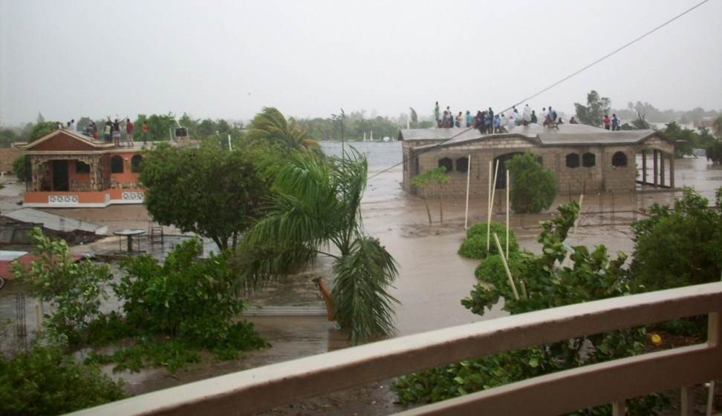
In the summer of 2008, Pastor Genada gave us a building with 3 rooms for our school. We bought all new textbooks, built new tables and benches, and had a very nice school. School opened September 1, 2008. It closed September 2, 2008.
On the night of September 1, 2008, Hurricane Hanna flooded Gonaives. The orphanage was under 14 feet of water. The children and staff spent 3 days on the roof. They put the youngest ones on a little tin roof over the stairway. The older children stood in the flood waters.

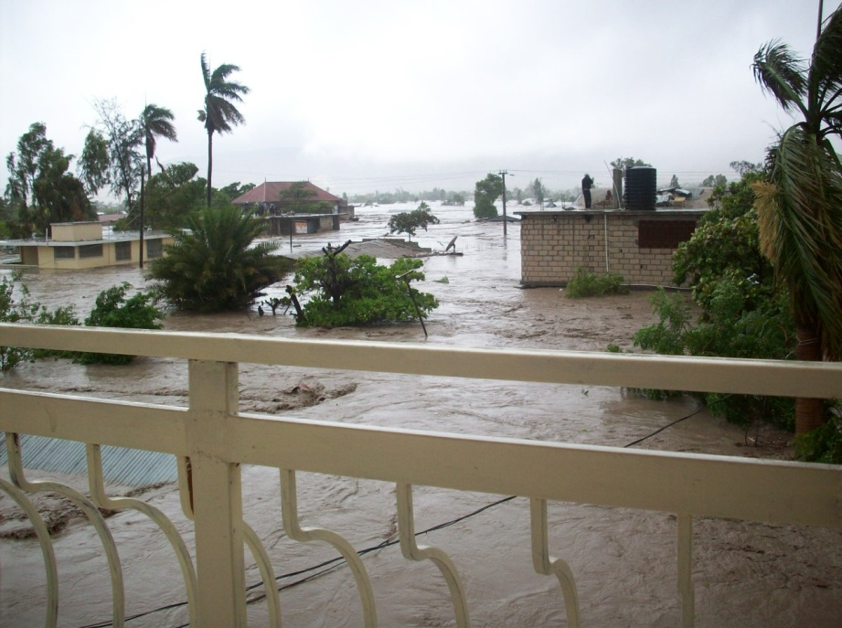
Pastor Genada got his family to the 3rd floor of a hotel. He could see the children on the roof, but could not get to them. The third day Pastor Genada managed to get the children off the roof and into the hotel. They had no food.
By September 5th, the waters had receded to about knee deep. Pastor Genada found some sacks of flour for a bakery. The flour on the inside was dry and clean. The children were given a handful of flour to mix in water to eat each morning and evening.
I offered to take the children until Pastor Genada could care for them again. He said, No, these are my children. I will care for them.”
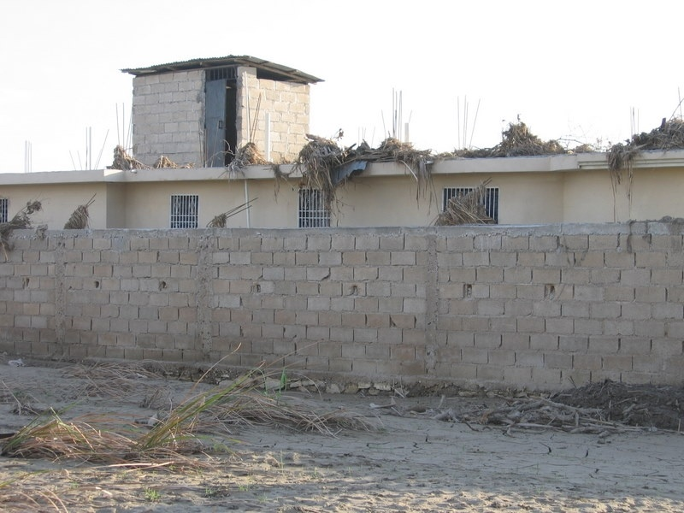
On September 8, 2008, Hurricane Ike flooded Gonaives again with 14 feet of water. This totally devastated and destroyed whatever had survived the first flood. Pastor Genada agreed to let us have the children on a temporary basis.
The orphanage in Gonaives
Water was over the roof.

We had a few days to prepare to receive 27 children. Where do we put them? We bought beds and mattresses. We asked local churches to donate clothes, sheets, towels, etc. We installed windows and doors in the gatehouse. We got the floors tiled.
We tried 3 times to have the children evacuated by helicopter. Because of miscommunication , every time we asked for help the help was diverted to another orphanage that did not need help which made the authorities angry. They wanted to help the truly needy first!!! There would be no rescue for our children because of the communication problem.
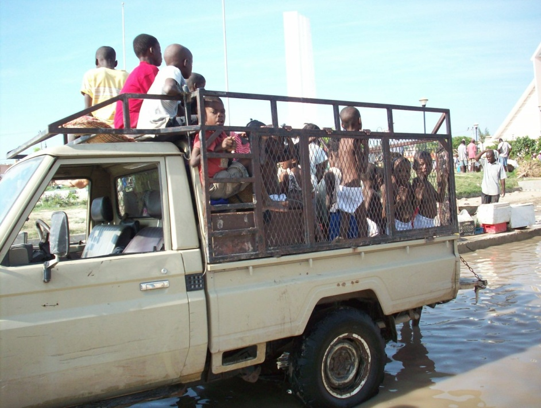
So, we arranged to go get them ourselves. A friend took a small team of rescuers, clothing, and food, etc. as far as Montrois where the bridge was out. Another truck came down to Montrois, then went up to Gonaives. On September 14^{th,} they brought the children back down to Montrois . The children crossed the river to the other truck waiting on this side.

The children arrived sick and weak. They had not had much to eat for 2 weeks. They were all very anemic from months or years of poor diet. We let them rest a few days, then began testing them for school. Three had been to school before. The younger ones started Pre-kindergarten. The rest tested out to kindergarten or first grade, so we made special classes for them.
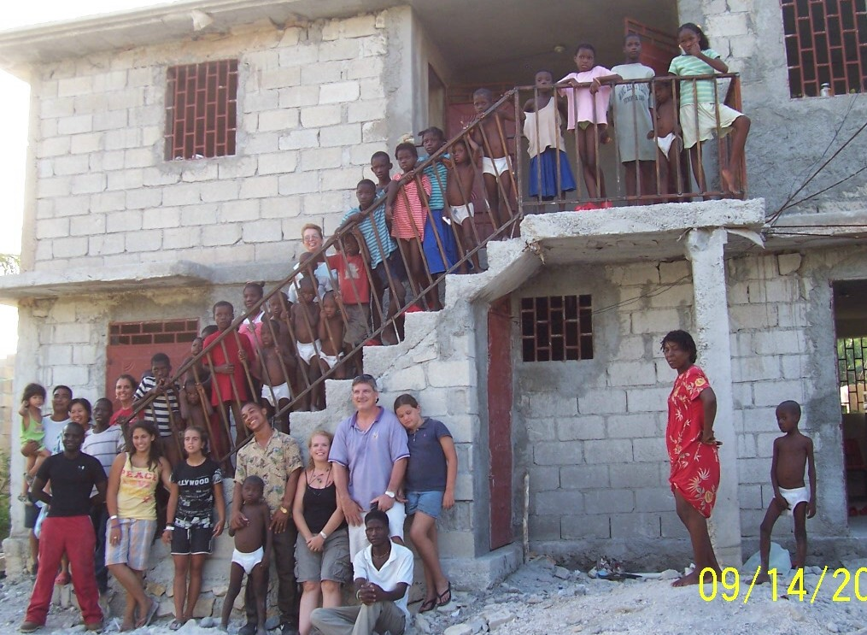
I am proud of the progress the children have made in 3 years. They have all learned English. The younger ones have progressed to second grade. Some skipped second grade and moved to third grade. Most of the older children are now in 5th or 6th grades regular classes in English and French.
Pastor Genada saw the great progress the children were making here. They became healthy and strong. They were all in school. He was homeless himself for 18 months. We all agreed that it was best for the children to remain here.
Since then we have taken in several malnourished children.
Our main ministry is our school. We can help many families with the school and change the future of Haiti with Christian leaders. We love the children we have in the orphanage, but it is not in the plans to have a big orphanage.
Our children are not up for adoption. Our children are all becoming well-educated. Haiti needs educated Christian leaders to remain in Haiti. Haiti needs for these children to stay here.

What happened to my school in Gonaives?
The roof fell in the floods. Everything was lost.
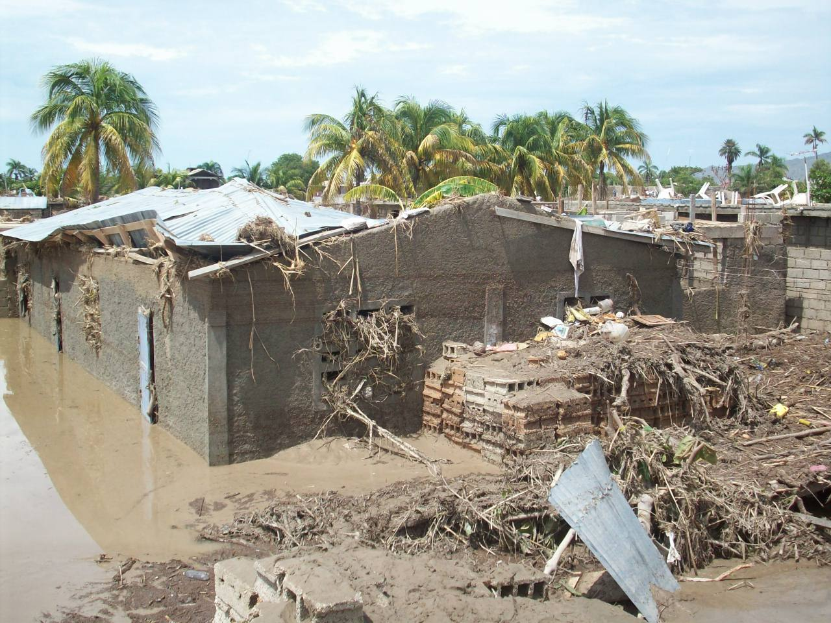
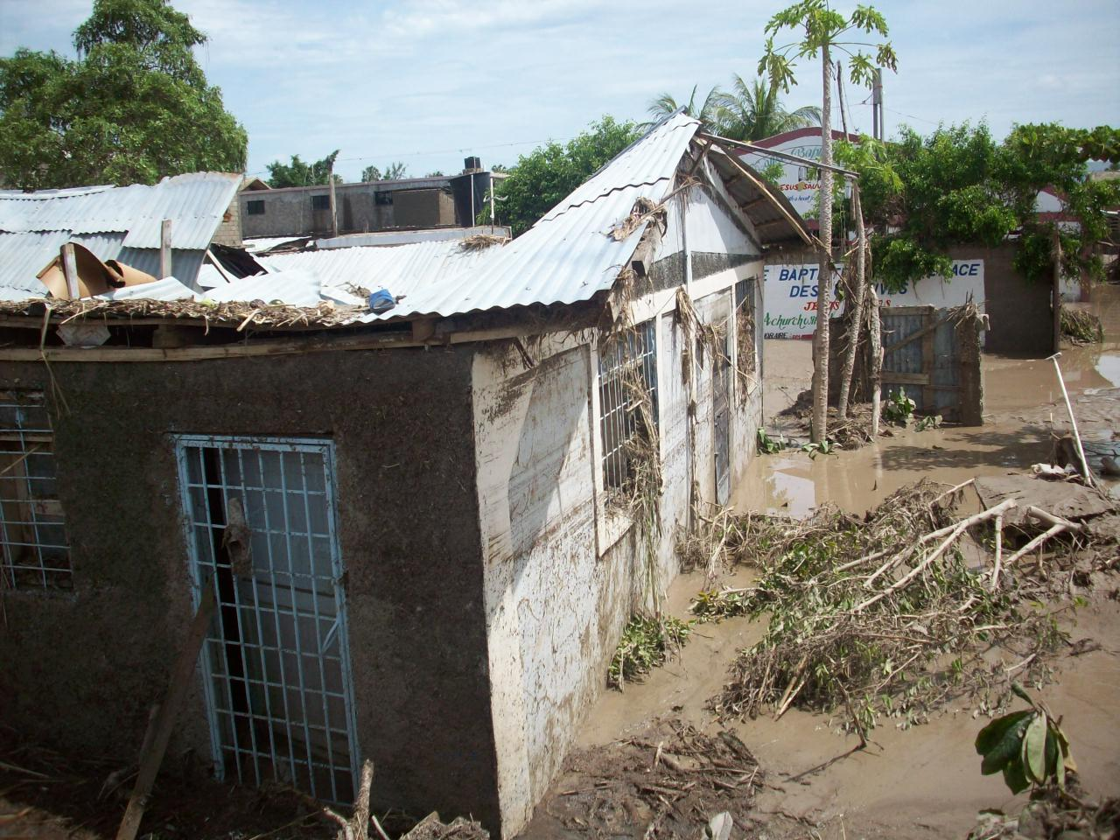
We had the children and that was just a building. We never went back.

